GenAI-Assisted Cloud Infrastructure Security Review System

1. Introduction
This mini project focuses on reviewing cloud infrastructure configurations and identifying potential security risks using a Python-based analyzer supported by Generative AI. The system analyzes configuration files related to EC2, S3, and IAM services and produces a technical review report with recommended security improvements.

2. Project Architecture
The project was implemented on an Amazon EC2 Linux instance. The analyzer script reads configuration files, detects risky patterns, and uses GenAI for advisory recommendations.

3. Folder Structure
genai-cloud-security-analyzer
│
├── analyzer.py
└── configs
├── ec2.json
├── s3.json
└── iam.json

4. Implementation Steps
- Launch an Amazon EC2 instance with Amazon Linux.
- Connect to the instance using SSH.
- Install Python 3 and required packages.
- Create the project folder 'genai-cloud-security-analyzer'.
- Add the analyzer.py script and configs folder.
- Create configuration files (ec2.json, s3.json, iam.json) with sample cloud settings.
- Run the analyzer script to scan configurations and identify risks.
- Generate a technical security report with recommendations.

5. Commands Used in the Project
sudo yum update -y
sudo yum install python3 -y
pip3 install openai
mkdir genai-cloud-security-analyzer
cd genai-cloud-security-analyzer
mkdir configs
nano analyzer.py
nano configs/ec2.json
nano configs/s3.json
nano configs/iam.json
python3 analyzer.py

6. Output Screenshot
Insert the execution output screenshot below:
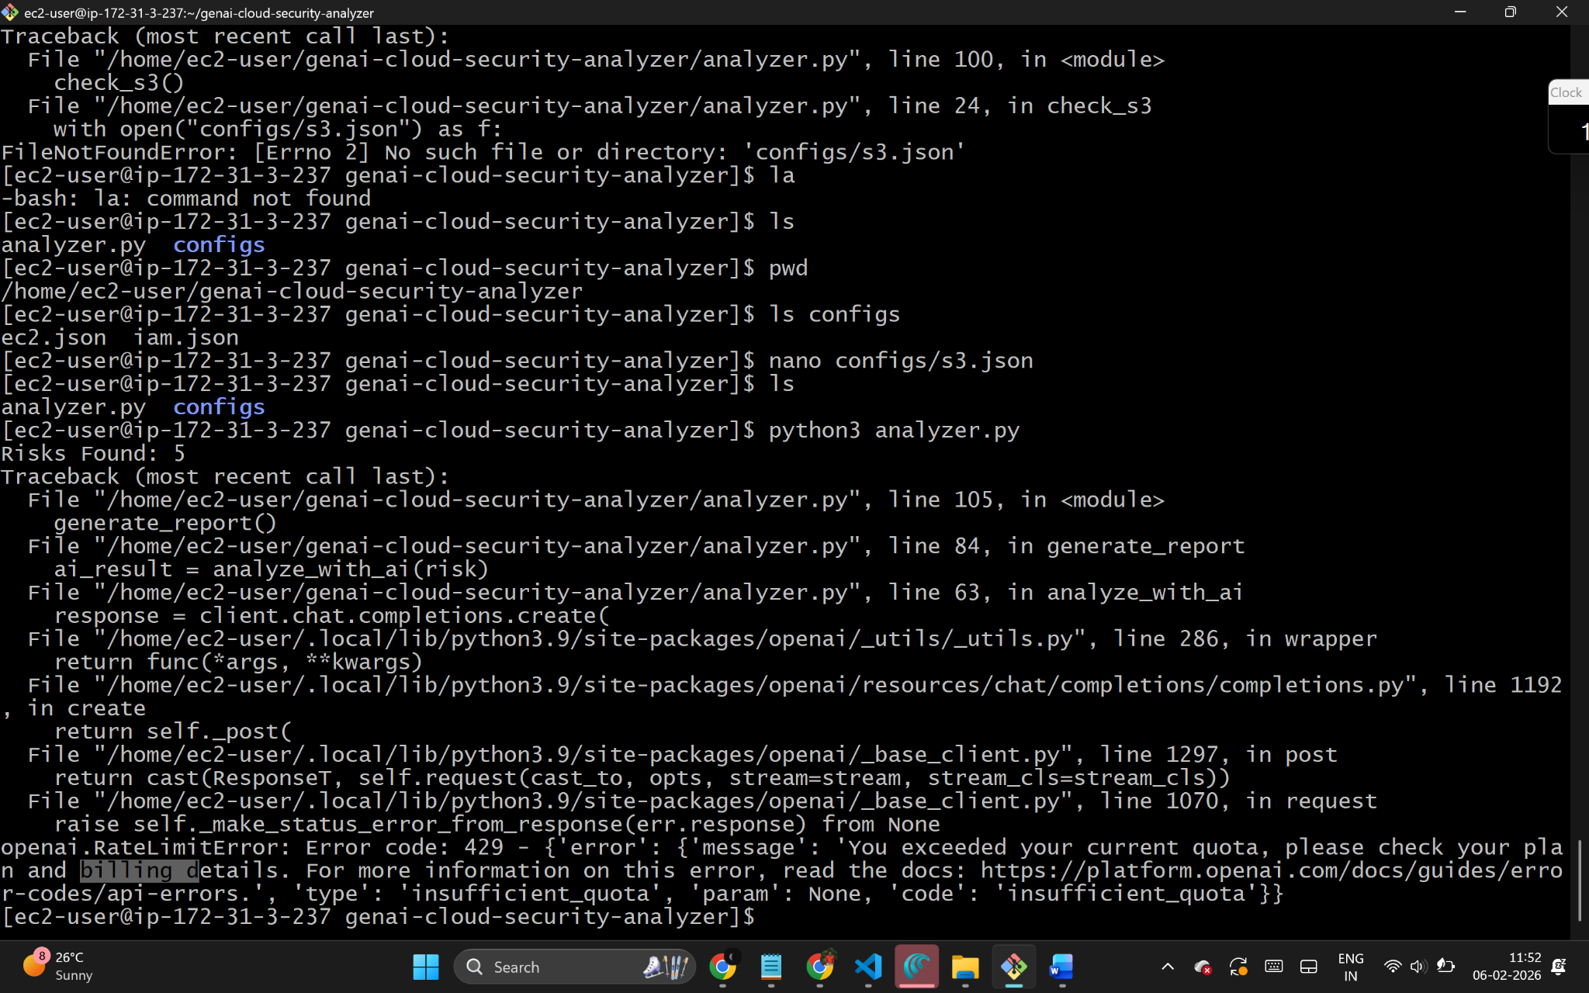

7. Results
The analyzer successfully detected misconfigurations such as public storage buckets, overly permissive IAM roles, and open security group ports. GenAI provided clear explanations of the risks along with recommended remediation steps.

8. Conclusion
This project demonstrates how Generative AI can assist in cloud security reviews by summarizing risks and suggesting improvements. It provides a simple yet effective approach for infrastructure auditing without enabling automated changes.

